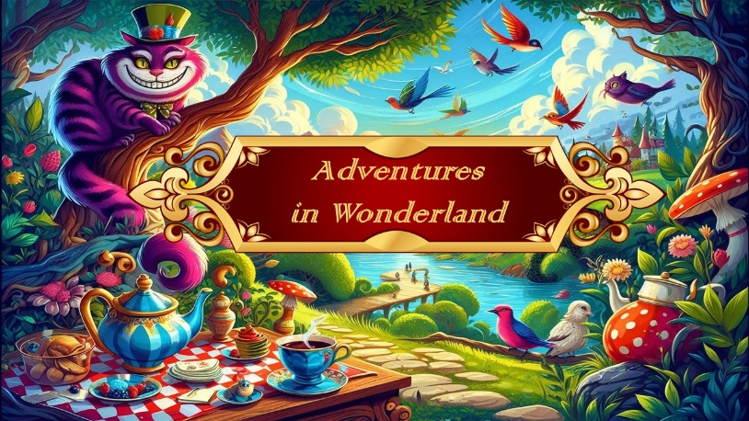

 |  | Shoes | Tights | Hair | Hair accessory | Other
Scene: Garden
Flower with the umbrellas | Pre Primary | Pink Ballet Shoes | Pink Tights | Bun | Flower crown | Umbrellas
Little rabbits | Creative & Tiny Tots | Pink Ballet Shoes | Pink Tights | Pig tails | Bunny ears
Little rabbits - Boys |  | Black Ballet shoes | Blue Socks |  | Bunny ears
Exotic birds | Grade 3 | Pink Ballet Shoes | Pink Tights | Bun | Feather fascinator
Dragonflies | Grade 4 | Pink Ballet Shoes | Pink Tights | Bun | Crown | Wings
Flamingos | Grade 5 | Pink Ballet Shoes | Pink Tights | Bun | Fascinator and scrunchie
Scene: Mad Hatters Tea Party

Topsy-Turvy Hatters | Int Tap Thurs | Black Tap shoes | Radanza tights | Pony tail\bun to work with Hat | Hats
Topsy-Turvy Hatters - Alex & Angus |  | Black Tap shoes | Socks provided |  | Hats
Cheshire Cats | Beg J & T - Jazz | Black Jazz shoes | Radanza tights, socks and gloves provided | Bun | Ears, Hair scrunchie
Cheshire Cats - Boys |  | Black Ballet shoes | socks and gloves provided
Tea party guests | Beg Ballet | Pink Ballet Shoes | Pink Tights | Bun | Hair bow
Scene : Along the roadside

Tweedles | Boys Hip Hop | Black Sneakers | Black socks
Scene: Queens of Hearts – palace

Trumpeters | Jnr Tap Sat | Black Tap shoes | Radanza tights, socks provided | Pony tail\bun to work with Hat | Hats
Roses | Primary | Pink Ballet Shoes | Pink Tights | Bun | Headband and Hair bow
March of the cards | Grade 1 | Pink Ballet Shoes | Pink Tights | Bun | Hair bow
Jester | Grade 2 | Pink Ballet Shoes | Pink Tights | Bun | Fascinator
Cheshire Cats | Beg J & T - Tap | Tap shoes | Radanza tights, socks and gloves provided | Bun | Ears, Hair scrunchie
Queens courtiers | Int F & Int F 2nd year | Pink Ballet Shoes | Pink Tights | Bun | Fascinator
Kings & Queens Trio |  | Pink Ballet Shoes | Pink Tights | Bun | Wendy's crowns
Kings & Queens Trio - Zac |  | Black Ballet shoes | Black tights with white socks
Merlitons | Nadia & Phoebe | Pink Ballet Shoes | Pointe shoes | Bun | Wendy's crowns
Hatterettes | Jnr Jazz Monday | Black Jazz shoes | Radanza tights, socks provided | Bun | Hair scrunchies

