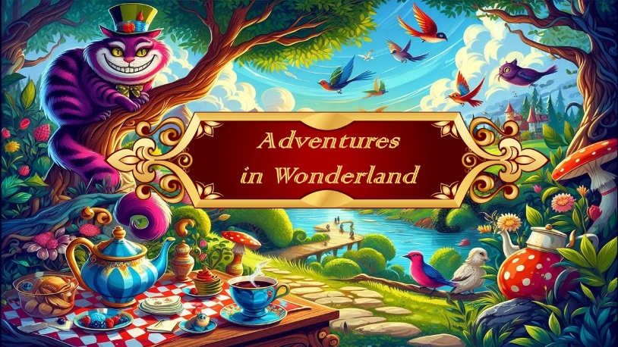
Scene: Garden
Flower with the umbrellas | Pre Primary
Little rabbits | Creative & Tiny Tots
Exotic birds | Grade 3
Dragonflies | Grade 4
Flamingos | Grade 5
Scene: Mad Hatters Tea Party
Topsy-Turvy Hatters | Int Tap Thurs
Cheshire Cats | Beg J & T - Jazz
Tea party guests | Beg Ballet
Scene : Along the roadside
Tweedles | Boys Hip Hop
Scene: Queens of Hearts – palace
Trumpeters | Jnr Tap Sat
Roses | Primary
March of the cards | Grade 1
Jester | Grade 2
Cheshire Cats | Beg J & T - Tap
The Tweedles & Mad Hatters arrive
The Queens court parade and the Queen of Hearts is crowned
Queens courtiers | Int F & Int F 2nd year
Kings & Queens PDD
Hatterettes | Jnr Jazz Monday
Coronation parade | Finale

