Lights, Music, Dance!
The show practices are in full swing, and we have got a lot of information within this notice.
Please take the time to read the whole update and ask your teacher if you have any questions.
Included in this notice:

- Reminder about tickets
- Upcoming practice times
- The big week at the theatre practice and performance times
- Shoes, tights and hair lists for all dances
- Help at the theatre
- Costume Accounts
- DVD, T shirts and Tote Bags
- Advertising in the program
- Facebook posts

Tickets
Tickets are on sale via trybooking - https://www.trybooking.com/DCIEX or via the QR code. Tickets for the Matinee are selling well so we encourage you to get your ticket orders in to avoid disappointment.

Adults |  | $40.00
Child | 13 and under | $25.00
Pensioners |  | $30.00
Students | 13+ years | $30.00
Performers | Performer ticket for dancers only, will be required to reserve a seat if they wish to sit and watch half of the show | $18.00
Upcoming Practices
The regular class timetable will remain until Saturday 1st November for Junior students.
Group rehearsals for the full performance run commence from the 8th of November.
All weekday classes for Junior students remain unchanged unless advised by your teacher.
West Ashgrove Uniting Church Hall is at the corner of 491 Waterworks Rd and Glory St in Ashgrove West. There is no available parking in the yard for our students and only limited surrounding street parking so please factor that into your travel plans. The dances will be performed in the correct order as they will be in the show.
It may be possible to run the dances twice during the sections. Please do not leave after the first run.
Dancers and parents can wait on the verandah or downstairs (when available) until it is time for their dance.

Please review the timetable careful to make sure when you need to attend.
Little rabbits’ parents please pay particular notice of the times and the change of the hall.

Costume fittings will be conducted across the weekends in November. Please ensure your student wears a leotard to all rehearsals for easy fittings.

There will be a BBQ, drinks and other snack items available for sale. Please let Wendy know if you can help.

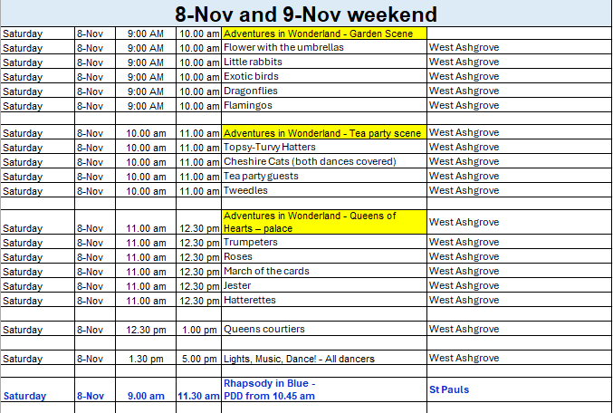

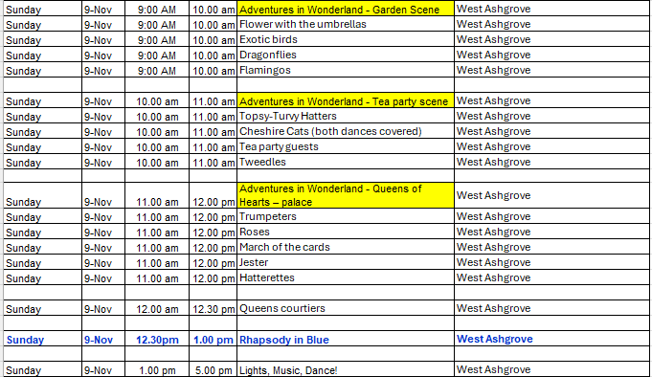

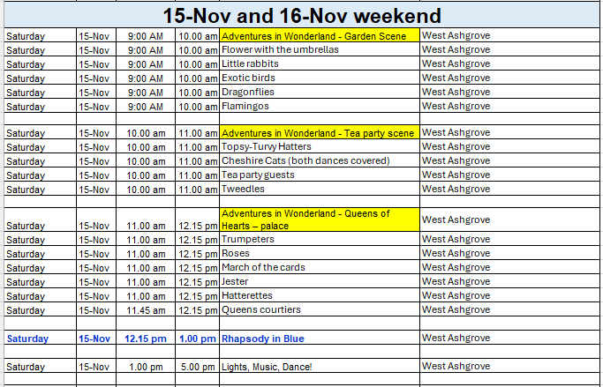

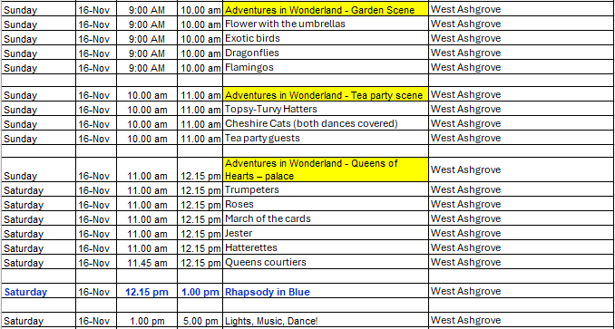

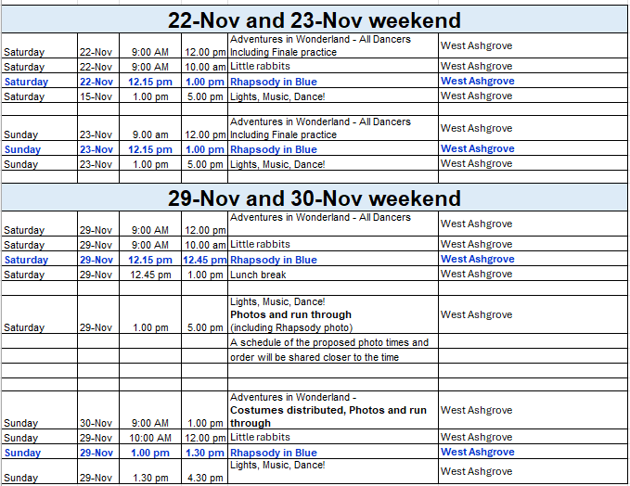

The big week at the theatre – practice and performance times
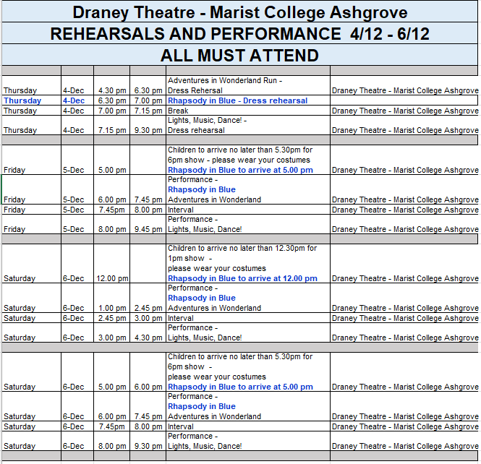

Shoes & tights for sale
Shoes and tights will be on sale at the run throughs, but we encourage you to get these early in the piece rather than the last weekend. All shoes should be cleaned before the performances.

Shoes, Hair and Tights listing
 |  | Shoes | Tights | Hair | Hair accessory | Other
Scene: Garden
Flower with the umbrellas | Pre Primary | Pink Ballet Shoes | Pink Tights | Bun | Flower crown | Umbrellas
Little rabbits | Creative & Tiny Tots | Pink Ballet Shoes | Pink Tights | Pig tails | Bunny ears
Little rabbits - Boys |  | Black Ballet shoes | Blue Socks |  | Bunny ears
Exotic birds | Grade 3 | Pink Ballet Shoes | Pink Tights | Bun | Feather fascinator
Dragonflies | Grade 4 | Pink Ballet Shoes | Pink Tights | Bun | Crown | Wings
Flamingos | Grade 5 | Pink Ballet Shoes | Pink Tights | Bun | Fascinator and scrunchie
Scene: Mad Hatters Tea Party

Topsy-Turvy Hatters | Int Tap Thurs | Black Tap shoes | Tan Chorus tights | Ponytail\bun to work with Hat | Hats
Topsy-Turvy Hatters - Alex & Angus |  | Black Tap shoes | Socks provided |  | Hats
Cheshire Cats | Beg J & T - Jazz | Black Jazz shoes | Tan Chorus tights, socks and gloves provided | Bun | Ears, Hair scrunchie
Cheshire Cats - Boys |  | Black Ballet shoes | socks and gloves provided
Tea party guests | Beg Ballet | Pink Ballet Shoes | Pink Tights | Bun | Hair bow
Scene: Along the roadside

Tweedles | Boys Hip Hop | Black Sneakers | Black socks
Scene: Queens of Hearts – palace

Trumpeters | Jnr Tap Sat | Black Tap shoes | Tan Chorus tights, socks provided | Ponytail\bun to work with Hat | Hats
Roses | Primary | Pink Ballet Shoes | Pink Tights | Bun | Headband and Hair bow
March of the cards | Grade 1 | Pink Ballet Shoes | Pink Tights | Bun | Hair bow
Jester | Grade 2 | Pink Ballet Shoes | Pink Tights | Bun | Fascinator
Cheshire Cats | Beg J & T - Tap | Tap shoes | Tan Chorus tights, socks and gloves provided | Bun | Ears, Hair scrunchie
Queens courtiers | Int F & Int F 2nd year | Pink Ballet Shoes | Pink Tights | Bun | Fascinator
Kings & Queens Trio |  | Pink Ballet Shoes | Pink Tights | Bun | Crown provide
Kings & Queens Trio - Zac |  | Black Ballet shoes | Black tights with white socks
Merlitons | Nadia & Phoebe | Pink Pointe Shoes | Pink tights | Bun | Crown provide
Hatterettes | Jnr Jazz Monday | Black Jazz shoes | Tan Chorus tights, socks provided | Bun | Hair scrunchies


Girls | Pink Ballet shoes | Pink Tights | Bun | Hair bows
Guys | Black ballet or jazz shoes | Black socks

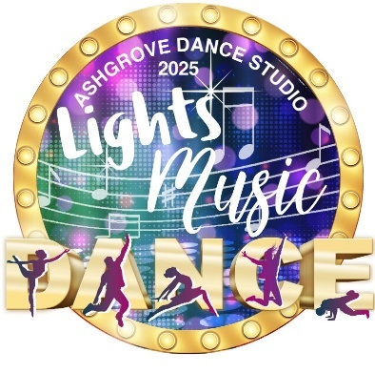
Dance | Shoes | Tights | Hair | Accessory
Opening | From your first costume or as advised by Wendy
The Seed | No Shoes | Tan Stirrup tights | Low pony | Hair ribbon provided
Anything Goes | Black Tap Shoes | Tan Chorus tights | Hair to suit hat | Sailor Hat
Dancing through Life | Pink Ballet Shoes | Pink Tights
Espresso Macchiato | See Elka
Dawn of the Sword | Pink Ballet Shoes | Pink Tights | Bun | Hair scarf scrunchie
Mission Impossible | Pink Ballet Shoes | Pink Tights | Bun | Scrunchie
What’s Up Danger | See Elka
Puttin on the Ritz | Black Chorus heels | Tan Chorus tights | Bun | See Rebecca
Don't Stop the Music | Ballet Tap Shoes | Black Socks | Bun
Higher Ground | Pink Ballet Shoes | Pink Tights | Bun | Red ribbon
Too Darn Hot | Black Chorus heels | Tan Chorus tights | Bun
Come What May | Pink Ballet Shoes | Pink Tights | Bun | Hair scarf
Honey Hot Rag | Silver shoes | Tan Chorus tights | Ponytail/fun hair to match your outfit | Headband with feather
Step in Time | Black Tap or Jazz Shoes | Tan Chorus tights red socks | Hair to suit hat | Hat
This is the Moment | Pink Ballet Shoes | Pink Tights | Bun
Barbie | Shoes to match your outfit | Tan Chorus tights or pink tights to suit your outfit | Ponytail/fun hair to match your outfit
Mein Herr | Black Chorus heels | Tan Chorus tights | Ponytail
76 Trombones | Black tap shoes | Tan Chorus tights, Boot covers socks provided | Hair to suit hat | Band top hat
Feathers | As advised by Wendy
Finale | As advised by Wendy

Help at the theatre
We’ll be running a canteen at the theatre so we will be looking for some volunteers. If you know you can assist at one of the performances, please let Wendy know.
Costume accounts
Costume accounts will be issued in the coming weeks. If you have paid a deposit, it will be deducted from your final bill. We request all accounts are paid by the 15 December.
Show merchandise
Tote Bags and T-shirts will be available with the show logo. There will also be a professional video of the show that will be made (probably on Sat Matinee).
No filming is allowed on your personal device whilst the performance is in progress.
To register you interest please complete this form – Show Merchandise - register your interest
Payment is not required yet, but we would like to have an idea of numbers. When payments are due you will be able to pay Eftpos or online if you prefer.
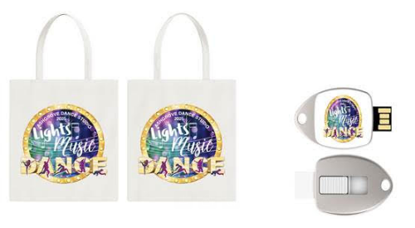
Tote Bag | $15.00
T shirts (Child) | $25.00
T shirts (Adult) | $30.00
DVD of Performance (probably Sat Matinee) | $80.00
USB of Performance (probably Sat Matinee) | $80.00

Advertising in the program
We will be producing a professional program for our performances at the Draney Theatre.
This is a fantastic opportunity to have your business recognised by local people. If you are interested in advertising, please call Judy to discuss- 0419 670 906. All advertisers will receive two free tickets to the show and a souvenir program.
1/6 Page | $90.00
1/3 Page | $120.00
1/2 Page | $180.00
Full Page | $220.00
A sample of last year’s program is available if you want to see the layout of our ads.
Our graphic designer is starting work on this next week, so we require finished artwork to be emailed to principal@ashgrovedance.com.au.

Facebook
We are encouraging everyone to follow Ashgrove Dance Studio on Facebook and would really appreciate sharing any posts about the show to help us spread the word.

