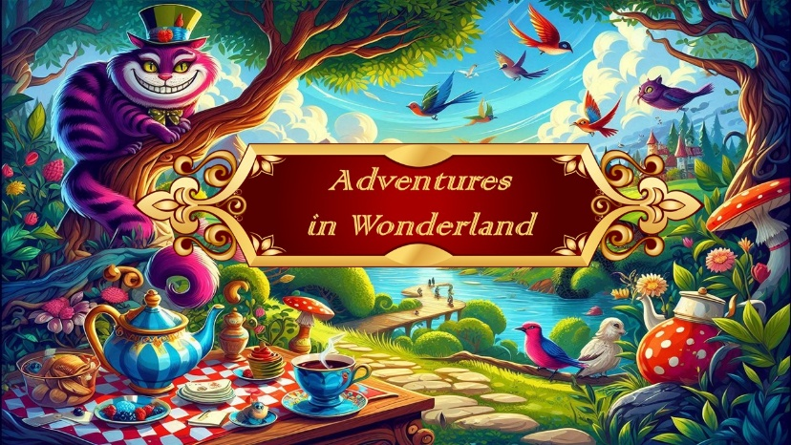

**Scene: Enchanted garden**

The White Rabbit awoke with a start, ears quivering, his pocket watch ticking like a drumbeat of doom. “Oh dear! Oh dear! It’s the day!” he squeaked, leaping from his burrow beneath the willow roots. Today was the Queen of Hearts’ coronation—the grandest affair in all of Wonderland—and he, had been entrusted to deliver the Royal Sceptre.

He scurried into the garden, where morning light spilled across petals of the flowers who were waltzing in time with a tune only they could hear. His little bunnies played joyfully in the sun. A great lake shimmered nearby, its surface kissed by dragonflies with jewelled wings. Along the banks, exotic birds in every hue of nonsense flapped and chattered. While the flamingos graciously pranced through the waterlilies

“Oh, what a morning to be late!” the Rabbit muttered

**Dances in the scene:**

|  |  |
| --- | --- |
| Pre Primary | Flowers |
| Creative & TT | Little Rabbits |
| Grade 3 | Exotic birds |
| Grade 4 | Dragonfly |
| Grade 5 | Flamingos |

**Scene : Mad Hatter tea party**

Onward he rushed—until he stumbled into an explosion of clinking china and chaotic chatter: **the Mad Hatter’s tea party**.

The table stretched in impossible directions, with teapots pouring themselves and chairs dancing with spoons. The Hatter stood atop a chair, raising a toast.

“Rabbit! Sit! Stay! Sip!” “No time!” Rabbit panted. “The Queen’s coronation!”

“You always say that,” said the **March Hare**. Out of no where there came a wide, gleaming grin

“Oh no,” Rabbit groaned. “*Not him.*” The **Cheshire Cat** appeared, swirling into view like smoke with stripes.

“You’re going *somewhere*, but *are* you going there?” the Cat asked,

“I *must* go there!” Rabbit said. “Then perhaps you already have,” the Cat mused. “Or never will. Or you are exactly where you need to be, which is far from where you’re going.”

The Hatter clapped wildly. “Brilliant! Brilliant!”

The Cat purred, vanishing into the wonderland madness…”

**Dances in the scene:**

|  |  |
| --- | --- |
| Int Tap Thurs | Topsy-Turvy Hatters |
| Beg J & T - Jazz | Cheshire Cats - Jazz |
| Beg Ballet | Tea party guests |

**Scene : Along the road**

The white rabbit dashed along the garden road in such a rush, he nearly collided with a familiar pair—Tweedledee and Tweedledum, spinning like tops and arguing over which direction led to the Coronation Glade.

“It’s *this* way!” Tweedledee insisted. “No, *that* way!” argued Tweedledum, pointing in the opposite direction—straight up. “Don’t be absurd!” Rabbit huffed, skirting around them.

“*Absurd*?” they gasped in unison. “Why, absurd is the only sensible thing left!”

He left them on the road and pressed onward.

**Dances in the scene:**

|  |  |
| --- | --- |
| Boys Hip Hop | The Tweedles |

**Scene : Queens of Hearts – palace**

As the White Rabbit arrived at the palace, bold, brassy trumpets echoed through the glade.

A path of red and white rose petals led the way, winding through the greenery toward courtyard. A parade of playing cards marched in perfect formation—the Queen was about to arrive.

Guests trickled in: the Hatter, the Cheshire Cat, and a curious cast of others. The Queen’s courtiers gathered—regal jacks, noble kings and queens—forming an assembly worthy of her majesty.

Suddenly, a fanfare erupted. The Queen of Hearts swept into view.

“You are late,” she says as the White Rabbit stumbled forward.

“But the sceptre is here, Your Majesty,” he wheezed, holding it high.

She examined it for a moment, then gave a single nod. “Very well,” she declared, seating herself on the throne. “Let the reign of hearts begin!”

The court erupted in celebration—courtiers twirled, Hatterettes boogied, and all of Wonderland embraced the joyous chaos of a new era.

As the festivities wound down and the stars blinked overhead, the White Rabbit finally allowed himself a breath.

Wonderland was a mad, mad place… but somehow, he’d survived. And—for now, at least—his head remained firmly on his shoulders.

**Dances in the scene:**

|  |  |
| --- | --- |
| Jnr Tap Sat | Queen’s Trumpeters |
| Primary | Roses |
| Grade 1 | March of the cards |
| Grade 2 | Jesters |
| Beg J & T - Tap | Cheshire Cats - Tap |
|  | The Tweedles & Mad Hatters arrive |
|  | The Queens court parade and the Queen of Hearts is crowned |
| Int F & Int F 2nd year | Queens courtiers |
|  | Kings & Queens PDD |
| Jnr Jazz Monday | Hatterettes (the Mad Hatter’s disco divas) |
| All dancers | Coronation parade- Finale |